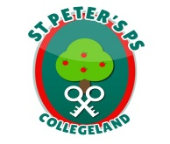
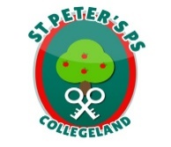
Parental Questionnaire February 2021

Dear Parents,
I am writing to you following the results of the recent Parent’s Survey on Home Learning by our School before Mid-term break. Results showed that over 90% of parents responded to the survey.
I wish to take this opportunity to thank you the parents for your continued cooperation in assisting the school in delivering the best possible learning opportunities for the children. There were a range of open comments which we will work through as a staff and will help inform future learning accordingly.
As a staff we agreed a balanced approach to home learning based on our professional knowledge of the children and our efforts to deliver the curriculum at each level.
This has indeed been a challenging time for us all but now we are moving to a phased return to school and face to face teaching.
As a school, we are continually working to improve our teaching and learning and value the input of parents, staff, Governors and children alike.
I continue to invite parents to bring any concerns to the school by making appointments via the school office as we look forward to a return to school.
Please see graphed results below.

Yours sincerely

Jim McAlinden
Principal

Questions and Results

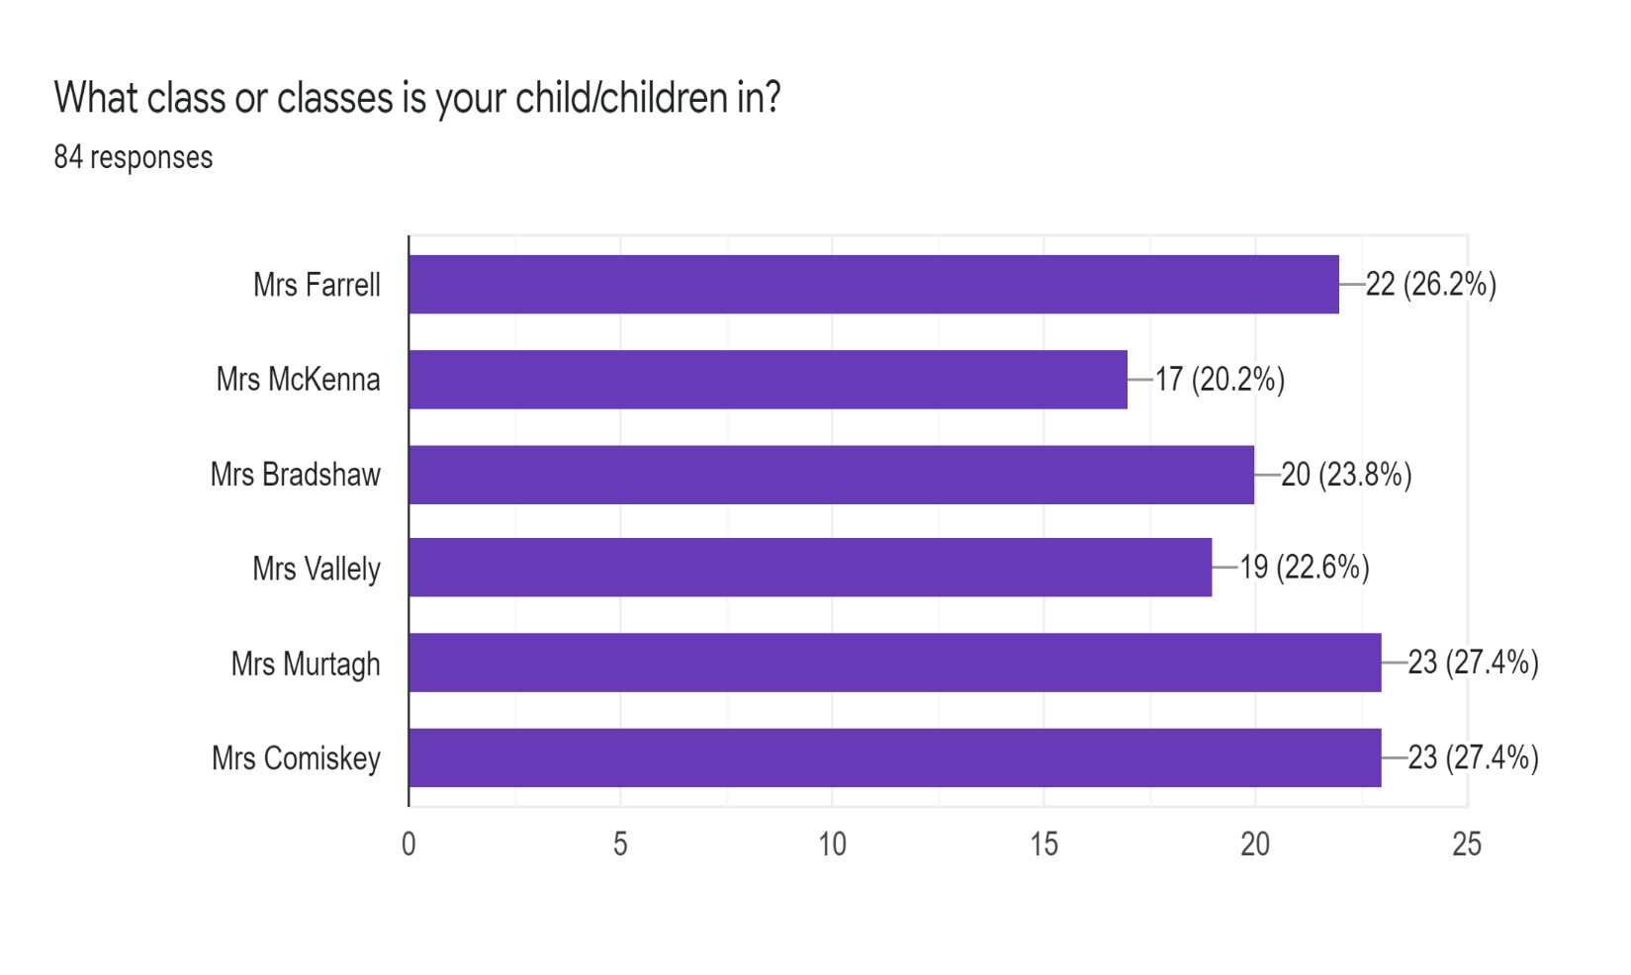
84 Families responded (90%), representing 124 children (86%).
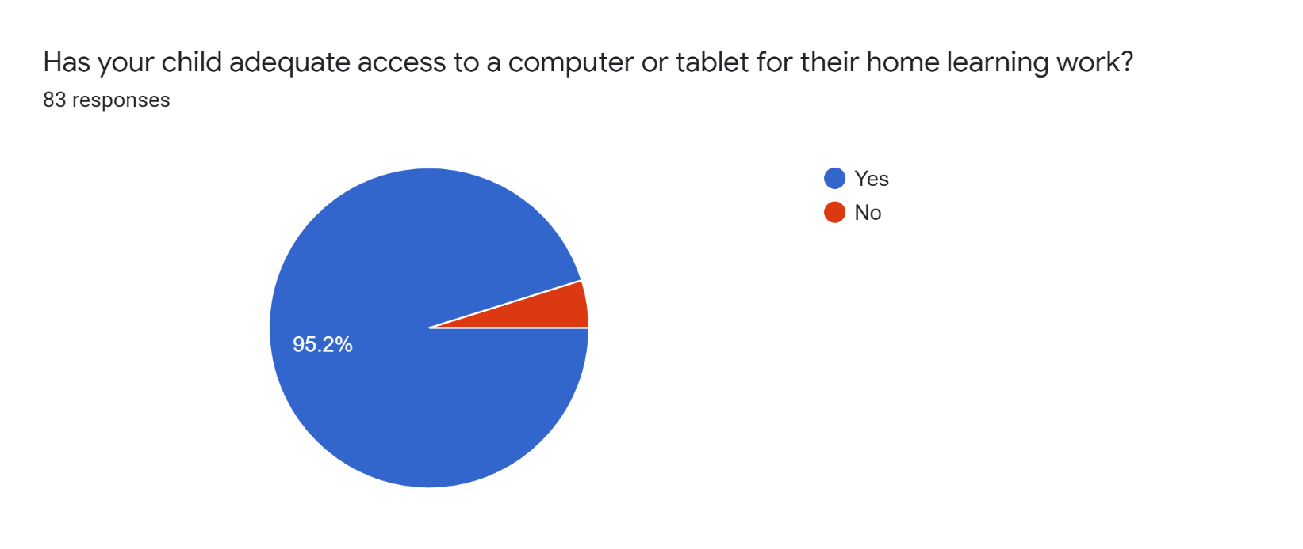
Home Learning Arrangement section 1
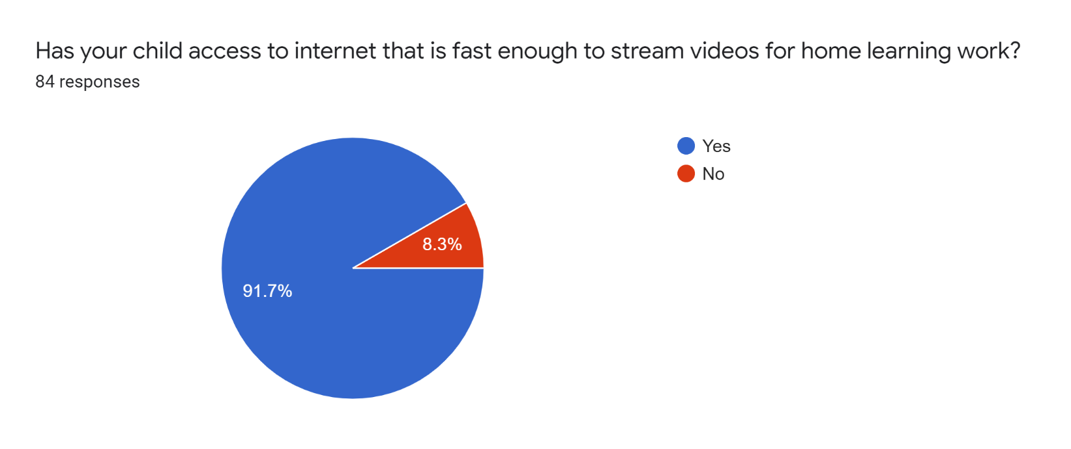

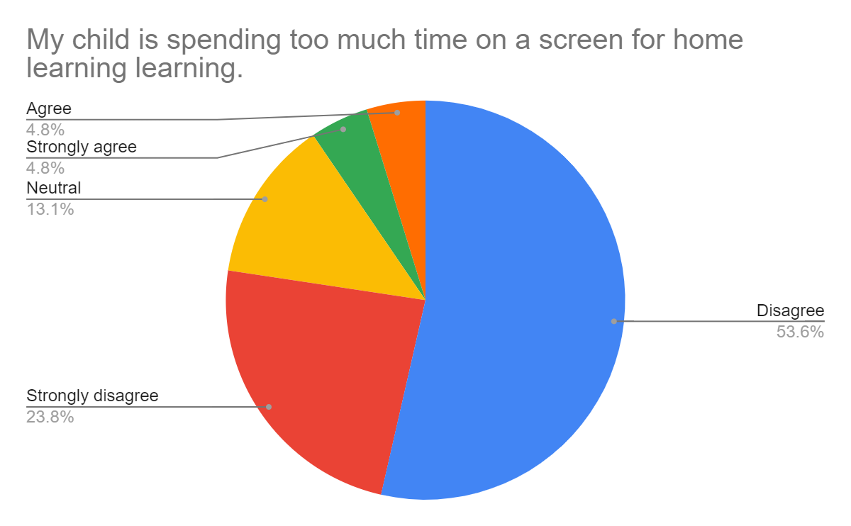

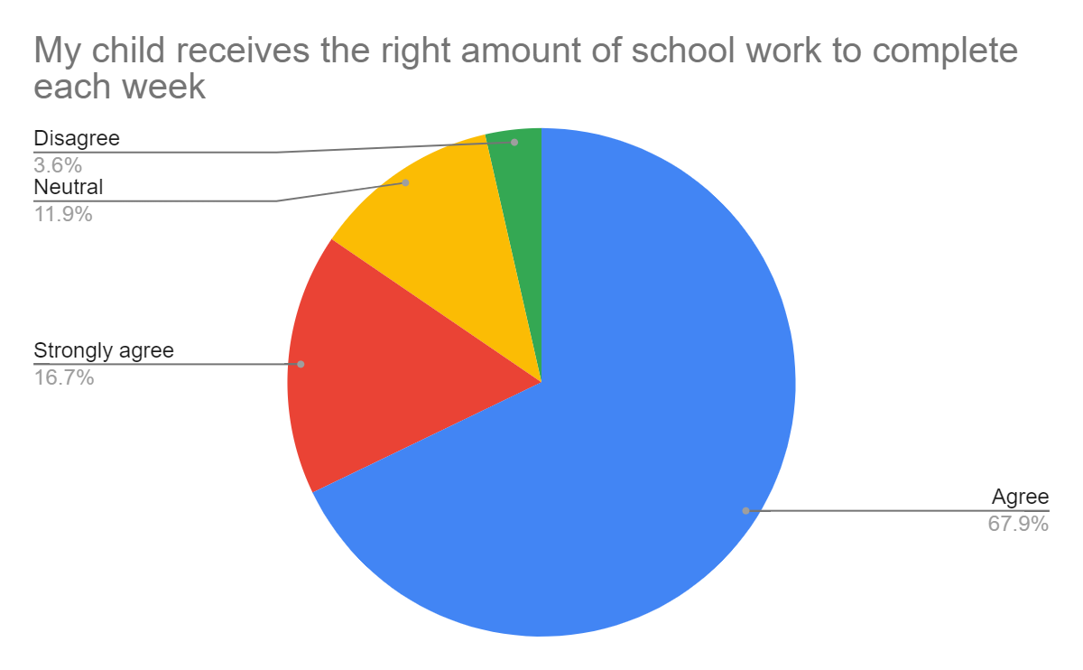

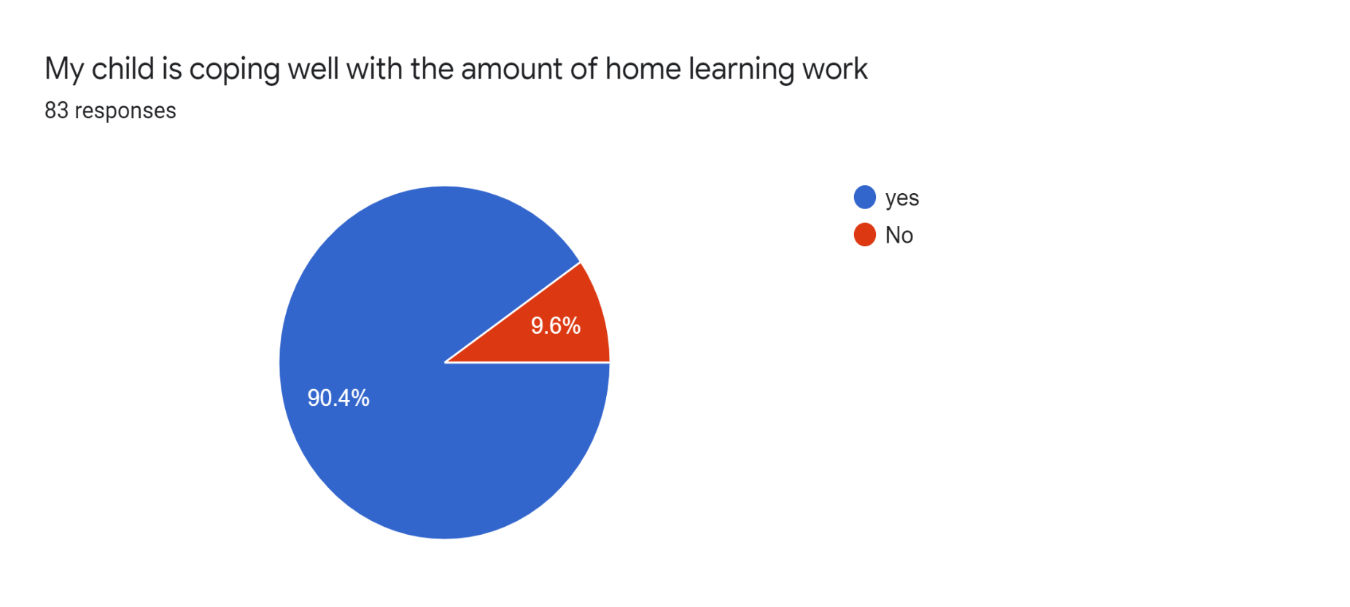
Wellbeing Section 2

