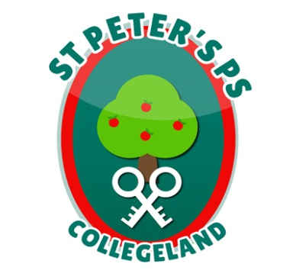
ST. PETER’S PRIMARY SCHOOL
90 Collegelands Rd
Charlemont
Moy
Co. Tyrone
BT71 6SW
Tel: 028 87 784620
Fax: 028 87 789672
Mob: 07860775105 Website: www.stpeterscollegeland.com
15th April 2021

‘Learning is Fun… Together as One’
Dear Parents,

DE needs parent’s views on the Scheme to deliver Direct Payments in lieu of Free School Meals and the School Holiday Food Grant Payment Scheme.

The Department of Education is currently evaluating the effectiveness of the two similar but separate payment schemes: a scheme to deliver Direct Payments In lieu of Free School Meals and the School Holiday Food Grant Payment Scheme. These schemes have been providing financial support of £13.50 per child per week, as necessary, to families of children entitled to Free School Meals since the start of the Covid-19 pandemic.

I have been asked to forward you the attached link to a short survey which will also assist the Department of Education in planning for any future payment schemes. I would encourage you to complete the online survey - it should take no more than 2 minutes.
DE Payment Schemes Survey
(you need to press Ctrl and then click together to open hyperlink above)

We are especially interested in the views of parents whose children are entitled to Free School meals.

If anyone has any trouble with this link please contact the school.

Regards

Jim McAlinden

