Dear Principal,
With the closure of all schools, both north and south of the diocese, and little prospect of a return to normality before the end of the academic year, I simply wanted to pass on my promise of prayer and best wishes to you and your school community.
You can find some prayer resources at the following link for these times, which I encourage you to share with your staff and parents, if you wish:
https://www.catholicbishops.ie/2020/03/16/prayer-resources-for-use-during-the-coronavirus-pandemic/
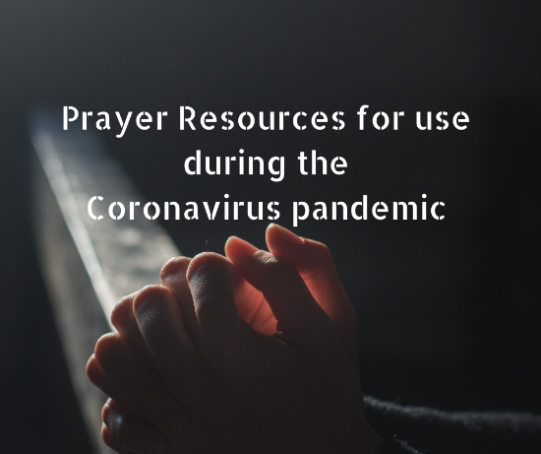 | Prayer Resources for use during the Coronavirus pandemic | Irish Catholic Bishops' Conference  The following prayers and resources are offered to assist the faithful during the threat of the coronavirus: Pope Francis’ Prayer to Mary during the coronavirus pandemic  www.catholicbishops.ie

I will be particularly mindful of you, your staff, pupils and their families at the altar as I celebrate Mass every day in private.
Pope Francis’ Prayer to Mary during the coronavirus pandemic
O Mary,
you always shine on our path
as a sign of salvation and of hope.
We entrust ourselves to you, Health of the Sick,
who at the cross took part in Jesus’ pain, keeping your faith firm.
You, Salvation of the Roman People,
know what we need,
and we are sure you will provide
so that, as in Cana of Galilee,
we may return to joy and to feasting
after this time of trial.
Help us, Mother of Divine Love,
to conform to the will of the Father
and to do as we are told by Jesus,
who has taken upon himself our sufferings
and carried our sorrows
to lead us, through the cross,
to the joy of the resurrection. Amen.
Under your protection, we seek refuge, Holy Mother of God. Do not disdain the entreaties of we who are in trial, but deliver us from every danger, O glorious and blessed Virgin.
Rev'd Ryan McAleer, VF
Diocesan Advisor for Primary Religious Education

