ST. PETER’S PRIMARY SCHOOL
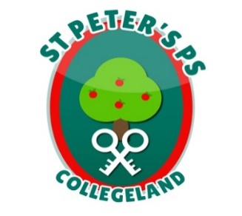
90 Collegelands Rd
Charlemont
Moy
Co. Tyrone
BT71 6SW
Tel: 028 87 784620
Mob: 07860775105
Website: stpeterscollegeland.com 15th September 2020

‘Learning is Fun… Together as One’
Dear Parent/Guardian,
As we settle in to the new school year it has been lovely to see the children coming into school smiling, happy to see their friends and feeling safe in school. Our priority remains getting the children comfortably back to five days per week at school.
At all times parents must make decisions based on the health and welfare of all pupils and staff. There are a number of updates posted on the school website and we encourage you to regularly check it (or download the app and you will be notified), and the messaging service for school communication.

It is VITAL that parents contact PHA on 0300 555 0119/ 0300 555 0114
(You must call from a mobile telephone.) BEFORE sending pupils to school if pupils display any of the symptoms of coronavirus. Please see latest PHA/DE poster on school website.
The normal school rules re sending sick pupils to school remain. Pupils with vomiting or diarrhea must always be kept at home for 48 hours after their last bout of illness. Please ensure you phone the office to inform us of their reason for absence.
The home school links Apps employed by the school are not a platform for enquiries or any other issues. The school policy remains that parents, if they have any concerns, raise this through contacting the school by phone and arranging a meeting. I will endeavor to respond to issues as quickly as possible.

Parents must continue to abide by the collection times for pupils and remember to keep a 2m distance from all other adults, including staff. A new Drop-off & Pick-up schedule will be posted this week on the website. Thank you for abiding by the one-way system.
Parents may not enter the school buildings/classrooms for the protection of all our children and we encourage the wearing of masks in the school grounds.
Thank you for your fantastic support to date. We are all in this together.
Yours sincerely
Jim McAlinden
Principal

