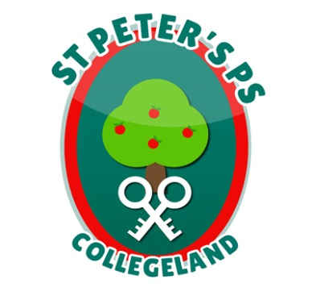
ST. PETER’S PRIMARY SCHOOL
90 Collegelands Rd
Charlemont
Moy
Co. Tyrone
BT71 6SW
Tel: 028 87 784620
Mob: 07860775105
Website: www.stpeterscollegeland.com 04th January 2021

‘Learning is Fun… Together as One’
Dear Parents
I hope you and your family are keeping well and have enjoyed the Christmas break.
Following recent advice on the current situation of the COVID19 epidemic, the levels of transmission and the number of positive cases, all Primary schools have been directed by Education Minister Peter Weir to teach children remotely until Monday 11th January when it is planned that schools will reopen for face to face teaching.
On Friday 8th January the school will be open to children of key workers. Online learning resources for year groups will be uploaded to the various school online platforms for Friday.
Peter Weir has asked schools to assist key workers who are maintaining essential public services, and who have exhausted all other options for childcare. The minister has also asked that we keep the number of pupils in school to a minimum. The fewer children making the journey to school, and the fewer children in educational settings, the lower the risk that the virus can spread and infect vulnerable individuals in our communities and wider society.
Every alternative childcare arrangement should be explored before deciding to send children to school. School should in effect, be a last resort.
Therefore, for those families where both parents are key workers, or one parent in the case of a single parent family and have no alternative childcare option, we will do our best to assist you in looking after your children.
This service will not be anything like a normal school day, the focus will be on child supervision rather than teaching.
We need to know how many children will be in school on Friday to make sure we have the staff to look after them and keep them safe. Therefore, in cases where parents are key workers and no other childcare options are available, we will endeavour to assist with childcare, from 9am - 3pm on Friday 8th January.
The criteria set by the Department of Education for key workers can be found here https://www.education-ni.gov.uk/news/weir-announces-changes-schools-reopening-arrangements
If you believe you fall into the category of parents who meet this prescriptive criteria, and would like to express an interest in acquiring a space in the day care please email jmcalinden640@c2kni.net before 3pm on Wednesday 6th January 2021.
Given the limited resources and the need to ensure the safety of all, we will need to prioritize those who are eligible. Your email should provide the names, phone numbers, occupations of both parents if applicable. If your occupations are not clearly detailed in Minister Weir’s list, please explain in detail why you believe you should be prioritized for this service.
We will assess each application in line with our capacity to deliver this service. We will contact all applicants on Wednesday evening and let you know if we can offer your child a place here on Friday 8th January. Places allocated will be reviewed as we have to consider the availability of a sufficient number of staff to provide a safe service.
We are most grateful to those keyworkers on the front line who are helping to fight this global pandemic. Please make sure to follow the most recent government advice to slow the spread of this virus and to give our wonderful NHS workers a chance to do their great work.
Yours Sincerely
Jim McAlinden

