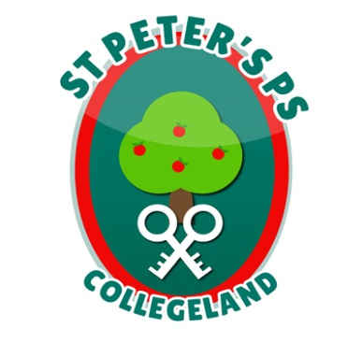
ST. PETER’S PRIMARY SCHOOL
90 Collegelands Rd
Charlemont
Moy
Co. Tyrone
BT71 6SW
Tel: 028 87 784620
Mob: 07860775105
Website: www.stpeterscollegeland.com 07th January 2021
‘Learning is Fun… Together as One’
Dear Parents
Following recent update on the COVID19 epidemic the school have had to make the following arrangements;
Staff will now utilize Friday 8th as a planning day to prepare resources for the term ahead. As staff will be sorting learning packs no online activities will be active on Friday.
From Friday 8th January the school will be open to children of key workers and vulnerable children only, until further notice.
These families will now be required to register their children for school via WhatsApp on the school mobile number 07860775105.
As before it would be necessary to let the school know how many children will be attending school so that appropriate supervision be put in place and we ask that parents notify school by Friday 3pm to cover the week ahead.
Learning packs will be available to collect in school on Monday 11th January, a staggered timetable for collection will be issued to parents tomorrow Friday.
The initial learning pack will be a user friendly resource to help parents establish home learning routines, incorporating a range of activities.
Teachers will continue to work via the various online platforms and communicate curriculum issues and updates as and when appropriate.
Please make sure to follow the most recent PHA guidance to ensure everyone’s safety.
Yours Sincerely
Jim McAlinden

