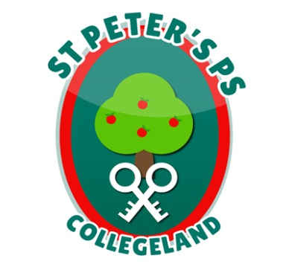
ST. PETER’S PRIMARY SCHOOL
90 Collegelands Rd
Charlemont
Moy
Co. Tyrone
BT71 6SW
Tel: 028 87 784620
Mob: 07860775105
Website: www.stpeterscollegeland.com 3rd February 2021

‘Learning is Fun… Together as One’
Dear Parents,
We have now been in this lockdown situation for 4 weeks. I would like to thank my teaching staff for the tremendous effort they have put into the online platforms and home learning packs. I would also like to thank our support staff who have been instrumental in providing assistance to teachers in their work and providing supervision for vulnerable and key worker children.
Whatever is asked of them the St Peter’s staff never fail to respond wholeheartedly.
I take this opportunity also to thank you, the parents for rising to the challenges of home learning.
I would like to reassure you, that we know you are doing your best and we are here to support you in any way we can. We are all parents and fully empathise with you. We understand the responsibilities you have and distractions that occur in a house on any day. If there is a day when home learning has to be cut short a little. let me reassure you, that’s ok. The health and wellbeing of our children and your families are paramount.
I have emailed out a short google survey to everyone that will help inform the school, how best we can continue to provide home learning. I ask for your cooperation in completing the survey. Please check your junk/spam boxes if it is not in your inbox. If you do not receive the survey please email Mrs Campbell at dcampbell448@c2kni.net and it will be resent to you.
I would also like to thank members of the wider school community who have in many different ways supported the school at this time.
I hope that you and your children will enjoy a ‘well earned’ break this mid-term.
Regards
Jim McAlinden

