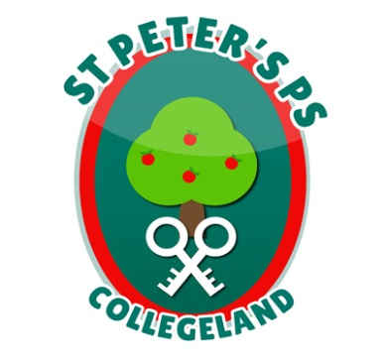
ST. PETER’S PRIMARY SCHOOL
90 Collegelands Rd
Charlemont
Moy
Co. Tyrone
BT71 6SW
Tel: 028 87 784620
Fax: 028 87 789672
Mob: 07860775105 Website: www.stpeterscollegeland.com

20th October 2021

‘Learning is Fun… Together as One’

Dear Parents,

For Halloween we will be holding a ‘Pumpkin Carving’ competition for the whole school. Pumpkins can be left into school on Monday 25th October and then taken home on Tuesday 26th October. Prizes will be given out on the Tuesday.

Wednesday 27th October will also be a fancy dress day but we ask that all children wear their PE gear underneath so that they can take part in the planned activities.

School will be closed from Thursday 28th October and we will return on Wednesday 3rd November.

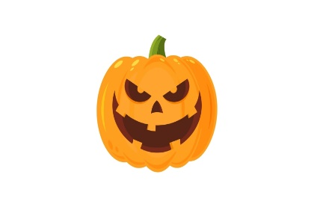
Please ensure that all Halloween activities are safe and that no child can come to harm over the Halloween break.

Yours sincerely

Jim McAlinden
Principal

