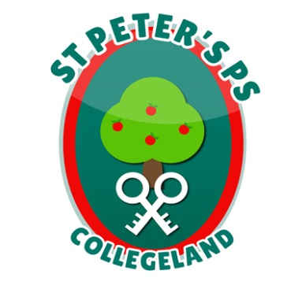
ST. PETER’S PRIMARY SCHOOL
90 Collegelands Rd
Charlemont
Moy
Co. Tyrone
BT71 6SW
Tel: 028 87 784620
Mob: 07860775105
Website: www.stpeterscollegeland.com 07-11-23

‘Learning is Fun… Together as One’

Dear Parents and Carers,
To celebrate the many positives of the internet, and to raise awareness of the issues that children and young people face online today, we will be hosting an online safety information session for parents and carers of children throughout the school.
This will be led by ‘Call Tech Support’ who will provide practical advice and safety tips to help manage online safety issues. The session is intended to raise awareness and encourage discussion surrounding suitable behaviour online.
We strongly advise that you attend this event. The session will be held on Tuesday 14th November 2023 in the School Hall at 7pm and will last for approximately one hour.
We believe that internet safety education is a crucial element of the curriculum and an essential part of young children’s development. This session is designed to enable you to strengthen and reinforce the safety messages that your children receive in school, in your home environment.
We really hope that you will be able to attend and look forward to seeing you there.
Yours sincerely
Jim McAlinden
Mr Jim McAlinden
Principal

